(i) a title, - done

(ii) the main figure produced in Python (ideally an integrated version comprising both the main one and small panels on the side), - done

(iii) the legend explaining the visualization components in the figure (e.g., what points, lines, and  
colors stand for), - done

(iv) findings text introducing highlights of the produced figure in  
bulletin points,

(v) data and method text describing the data and method used in this  
process, and

(vi) a significance statement on why the presented figure is an important  
topic.

A three-page maximum PDF containing these four components is required to be  
submitted due before the week-12 class.

The submitted PDF should also include a link to  
a newly created GitHub page that archives the used Python code, data source, and the  
report itself as the documentation.

Mapping Student Enrollment Distances in Pittsburgh Public Schools

Pittsburgh public school students are eligible for transportation if they live more than 2 miles there from school. A neighborhood school, also known as your feeder school, is the district school assigned based on the home address. Neighborhood schools are usually within 5 miles, about 8 kilometers, of the home.

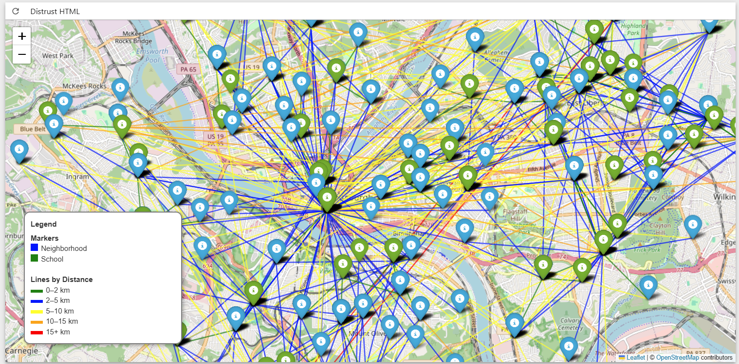

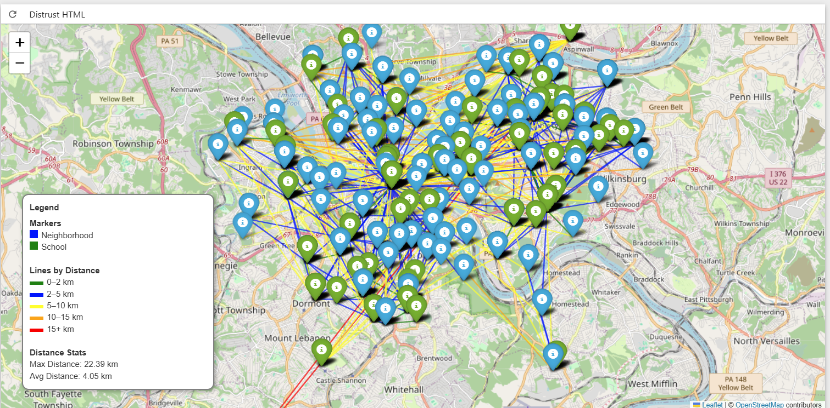

The maps above visualizes the relationship between neighborhoods and the schools attended by students, with each colored line representing the distance traveled from a student's neighborhood to their school. After generating the map, I analyzed the distance data. The three most frequently attended schools in Pittsburgh Public Schools are Pittsburgh Allderdice High School, Pittsburgh Brashear High School, and Pittsburgh Colfax K-8. Notably, 80% of students are enrolled in their designated neighborhood school. On average, students travel 7.40 km to school, with the farthest distance recorded at 18.42 km. Additionally, 13.4% of students travel more than 8 km—the threshold for being considered outside a neighborhood school zone in Pittsburgh—and 2.6% travel more than 15 km.

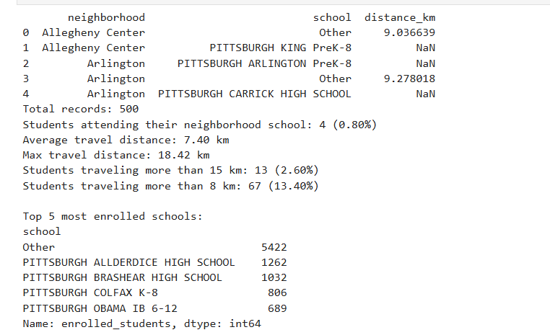

Data and Methods

The data sets that I used are from Allegheny County Western PA Regional Data Center. The data was extracted from the Pittsburgh Public Schools data system in January, 2021. It captures the school where the student was enrolled on October 1st. This dataset includes schools, feeder pattern / attendance boundary, and by neighborhood.

Each location was geocoded using the Google Maps API to obtain latitude and longitude coordinates. The straight-line (great-circle) distance between neighborhoods and schools was calculated using the Haversine formula. These distances were then visualized on a Folium map with lines color-coded by distance ranges to show proximity relationships.

Significance statement

Understanding the distances students travel to attend school is crucial for assessing educational accessibility and equity. This visualization aids policymakers and educators in identifying areas where students may face longer commutes, potentially impacting attendance and performance. By highlighting these patterns, stakeholders can make informed decisions to enhance the efficiency and fairness of school assignments.

GitHub Link: